SLIDE 1

PRESENTATION TO THE INCLUSIVE PRACTICES CONFERENCE, OCTOBER 2018, ON THE IACD INTERNATIONAL STANDARDS FOR COMMUNITY DEVELOPMENT, BY CHARLIE MCCONNELL, IACD PAST PRESIDENT AND CHAIR OF THE INTERNATIONAL STANDARDS WORKING GROUP

SLIDE 2

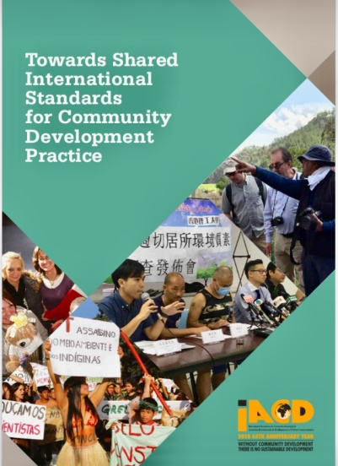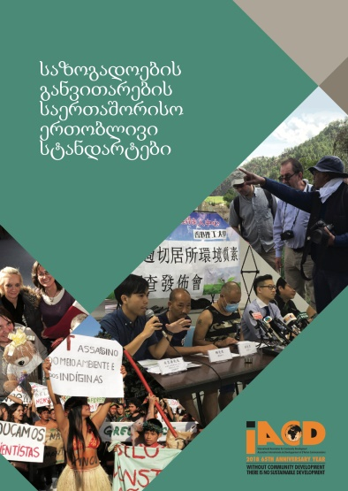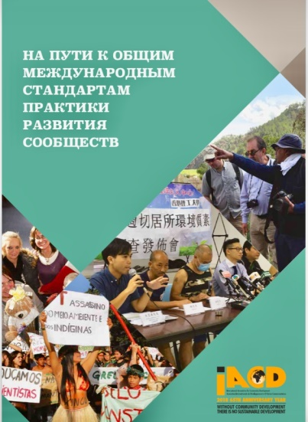

CHINESE, SPANISH, FRENCH, ARABIC, HINDI AND SWAHILI LANGUAGE VERSIONS TO FOLLOW (PERHAPS MORE)

SLIDE 3

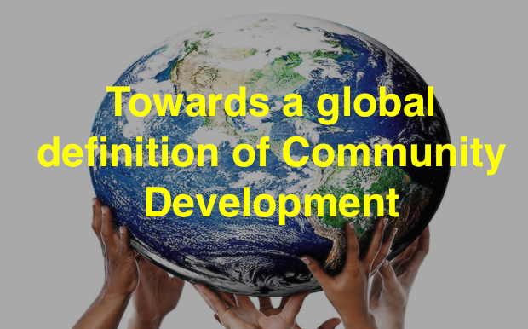

SLIDE 4
Community development is a practice-based profession and an academic discipline that promotes participative democracy, sustainable development, rights, economic opportunity, equality, and social justice, through the organisation, education, and empowerment of people within their communities, whether these be of locality, identity, or interest, in urban and rural settings.

SLIDE 5
To do this challenging, work, practitioners need:
- an understanding of political, social and ecological sciences to give them wider insights into the inter-connected realities of people’s lives, of the contexts within which people live and of how to achieve change that empowers people.
- skills in communication, in how to be effective educators and organisers, in how to access resources, in how to be empathetic.
- to commit to what we see as universal values of social and environmental justice and democratic participation.

SLIDE 6
Standards for community development describe what a person needs to do, know and understand to carry out good quality community development practice.

SLIDE 7
Community Development practice is carried out by people in different roles and contexts.
- People explicitly called professional community workers;
- Professionals in other occupations ranging from social work, education, youth work, health disciplines etc. who seek to apply community development values and adopt community development methods.

SLIDE 8
Underpinning values
The commitment to rights, solidarity, democracy, equality, environmental and social justice.

SLIDE 9

The purpose of community development
To work with communities to achieve participative democracy, sustainable development, rights, economic opportunity, equality and social justice.

SLIDE 10

The methods and processes
The organisation, education and empowerment of people within their communities…”

SLIDE 11

We identified eight key practice areas that are common across practice in community development across the world.
- Putting values into practice - Understand the values, processes and outcomes of community development, and apply these to practice in all the other key areas
- Engaging with communities - Understand and engage with communities, building and maintaining relationships with individuals and groups
- Ensuring participatory planning - Develop and support collaborative working and community participation
- Organising for change - Enable communities to take collective action, increase their influence and if appropriate their ability to access, manage and control resources and services.
- Learning for change - Support people and organisations to learn together and to raise understanding, confidence and the skills needed for social change
- Promoting diversity and inclusion - Design and deliver practices, policies, structures and programmes that recognise and respect diversity and promote inclusion
- Building leadership and infrastructure - Facilitate and support organisational development and infrastructure for community development, promoting and providing empowering leadership
- Developing and improving policy and practice - Develop, evaluate and inform practice and policy for community development, using participatory evaluation to inform and improve strategic and operational practice.

SLIDE 12
In developing these standards, our intention is to offer them as a guide for practitioners, education and training providers, employers, regional and national CD associations and to national governments, to be used to enhance the quality of community development practice and the quality of professional development programmes and opportunities.

