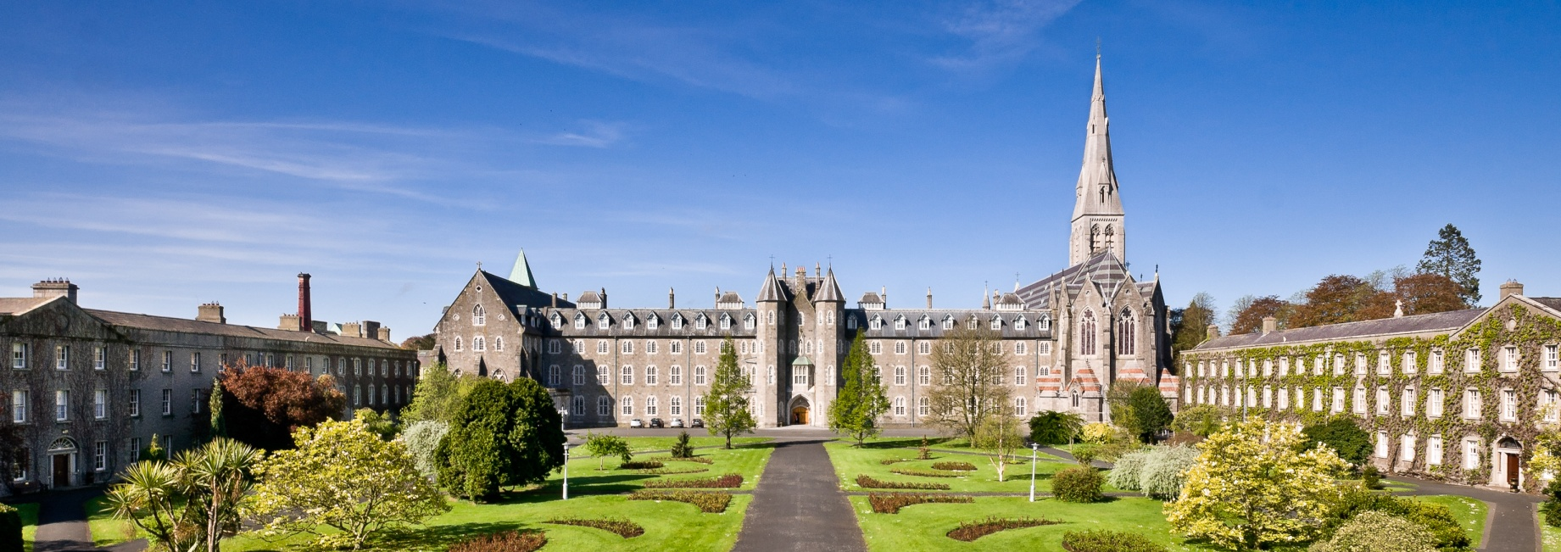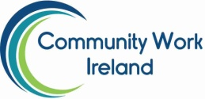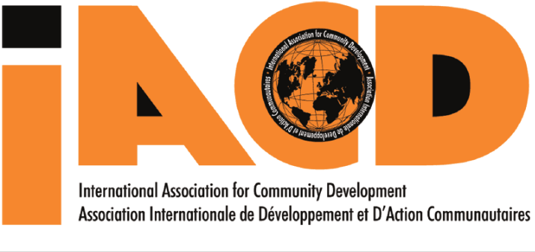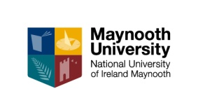

**World Community Development Conference 2018**

**IACD, COMMUNITY WORK IRELAND & MAYNOOTH UNIVERSITY**

invite you to

**Participation, Power and Progress: Community Development towards 2030 - Our Analysis, Our Actions**

**24-27 June 2018**

**Maynooth University, Kildare, Irelan www.wcdc2018.ie**

**World Community Development Conference 2018**