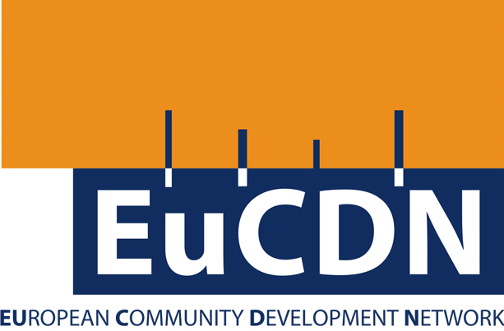

**Across Europe there is an emergent politics characterised by populism, nationalism and tribalism. All of these characteristics are contrary to the principles and practice of community development; moreover there is an apparent decline in the funding, workforce and influence of community development itself. Community development practitioners and organisations now need to ask some critical questions if we are to succeed in challenging these negative trends. Can we build a stronger national and international voice with a greater impact on policy, government and public opinion?**

If Europe is to develop effective policies to tackle the major challenges it faces then the process of developing them must take account of the reality and the experience of people who are affected directly by the issues.

The seminar is for practitioners, politicians and others who wish to learn from each others’ experience, to identify the key challenges we face and how they could be tackled with community development. From this, we hope to build the case for governments and others to invest in community development as a means of securing a more inclusive, just and sustainable Europe. This will be the first of a series of discussion EuCDN proposes to focus on the key challenges that Europe must address energetically and about which community development workers have something really important to say.

For further information and to secure a place please contact the EuCDN Co-ordinator, Alex Downie, on [alexander.downie@btopenworld.com](mailto:alexander.downie@btopenworld.com)

**The threat to democracy: A core issue for community development**

**Krakow, Poland**

**Wednesday 31 May**

Practice and Policy exchange:

The challenges

we face across Europe